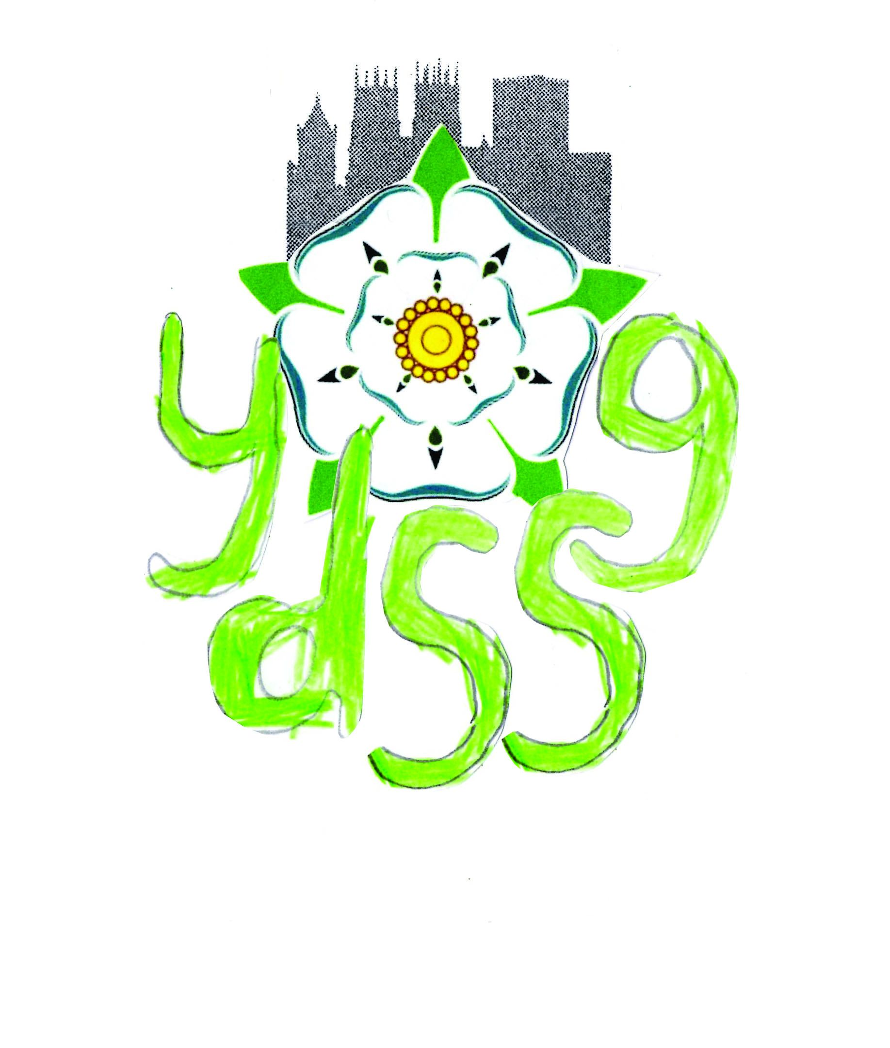

York Down Syndrome Support Group

Equality and Diversity Policy

Section 1 Equality and Diversity Statement

1.1 YDSSG aims to promote equality and diversity as a prospective employer and seeks to ensure that equality and diversity principles underpin all areas of the Group’s work and service provision.

1.2 YDSSG recognises that many people and groups suffer discrimination and face serious barriers when trying to fulfil their true potential. It also recognises that not all forms of unreasonable and unfair discrimination are the subject of legislation. It is the aim of this Group to take positive steps to redress discrimination, to improve equality of opportunity and to combat any unreasonable or unfair treatment which places people at a disadvantage for any reasons not directly related to their ability to do a job for this Group or to their eligibility to receive services from us.

1.3 In most cases it is unlawful to discriminate against people on grounds of gender, pregnancy, race, colour, nationality, ethnic and national origin, sexuality/sexual orientation, religion or belief, age, or because they are disabled, married, a member of a trade union, work part time or on a fixed-term contract.

However we recognise that people may experience discrimination for many additional social, educational and economic reasons such as their language, health, physical or mental disability, HIV status, caring responsibilities, trade union activity, where they live, how they speak and whether they work flexibly. This policy will apply equally to all these circumstances.

1.4 YDSSG will not tolerate discrimination, harassment, bullying, victimisation or abuse of people who are members of staff or of people connected with the services provided by Down Syndrome Training & Support Service Ltd.

Section 2 Management Issues and Delivery Mechanisms

2.1 YDSSG’s committee has ultimate responsibility for the equality and diversity policy. It is however the responsibility of the activity or project co-ordinator to implement, monitor and evaluate the equality and diversity policy in terms of employment practice and service delivery. S/he is also under a duty to ensure that the Committee is regularly kept informed of the policy's implementation and the implications of the Committee’s s decisions and policies for equality and diversity issues.

    - All employees. volunteers and members will be informed that an equality and diversity policy is in operation and that they are bound to comply with its requirements. The policy will also be drawn to the attention of YDSSG’s funding agencies, job applicants and those using the services of YDSSG.

2.3 Staff and Volunteers are to be given a copy of the whole policy upon appointment/election and whenever the policy is modified. A copy of the policy will be made accessible on the YDSSG website.

2.4 Complaints about any aspect of the Group’s services should be made directly to the Committee.

2.5 YDSSG seeks a broad and representative committee.

2.6 It is expected that when staff or committee members represent YDSSG on the committees of other agencies they will endeavour to ensure that equality and diversity principles and practices are adopted by those agencies.

Section 3 Employment Practices

3.1 YDSSG aims to promote equality and diversity as an employer and to ensure that no job applicant or employee receives less favourable treatment or is disadvantaged by conditions or requirements that cannot be shown to be justifiable within the context of the policy.

3.2 YDSSG regards discrimination, harassment, abuse, victimisation or bullying of staff, clients or of others in the course of work as disciplinary offences that could be regarded as gross misconduct. Condoning such behaviour could also be treated as a disciplinary offence. As well as disciplining the perpetrator(s), we will give appropriate support to people who complain of harassment of themselves or others.

3.3 Selection, recruitment, training, promotion and employment practices generally will be subject to regular review to ensure that they comply with the equality and diversity policy. In particular, selection and recruitment procedures should be reviewed no less than annually in order to try and constantly improve equality and diversity practices.

    - YDSSG will attempt to accommodate staff requests to work flexibly, whether part-time or some other working arrangement, for whatever reason, so long as agreement is consistent with the needs of the Group. YDSSG allows for paternity and partner leave in addition to standard maternity leave, in accordance with current legislation. Allowance is also made for compassionate and dependant’s leave to deal with domestic emergencies.

3.5 We recognise that Groups are obliged under the Disability Discrimination Act to make reasonable adjustments to accommodate disabled people and to enable them to do their job without unnecessary difficulty. We will make adjustments which are reasonable, whether or not we are obliged to do so by law, and whether or not a disabled applicant or employee is covered by the definition of disabled under the DDA.

  - We accept our obligation not to discriminate against applicants and employees on the basis of their religion or belief. We will try to accommodate employees’ religious beliefs by:-

Allowing time and if possible a place for prayers during the working day and at the workplace.

Considering employees’ dietary requirements in catering for staff and when providing facilities for staff to eat and store food.

Allowing staff of particular faiths to take their holidays for religious festivals and other religious observance.

Trying to arrange job interviews or other important work meetings at times when they do not clash with important religious festivals.
Not imposing a dress code with which people of a particular religion cannot comply.

3.7 YDSSG will not discriminate on grounds of age in recruitment, promotion, training, or the availability of benefits such as pension contributions or health insurance. Down Syndrome Training & Support Service Ltd will consider seriously any application to work beyond the retirement age of 65

    - Training or education development to enhance potential within the existing role, arising out of needs identified where appropriate or possible, be provided by YDSSG.

  - YDSSG will take whatever positive action is required where it can be shown that under-representation of any particular group has occurred in recruitment. Where appropriate and where legally permissible, employees from under-represented groups will be given training and encouragement in order to promote equality and diversity within YDSSG

  - All training opportunities will be published widely to all appropriate employees, volunteers and members and not in such a way as to exclude or disproportionately reduce the numbers of applicants from a particular group.

Section 4 Service Delivery

4.1 YDSSG seeks to ensure that its services are accessible to all sections of the community served by YDSSG.

4.2 YDSSG will make public its commitment to combating discriminatory attitudes where these are encountered.

4.3 YDSSG will attempt to ensure that none of its policies discriminate directly or indirectly against any group or individual.

4.4 The committee will adopt job descriptions which specifically address the equality and diversity aspects of all areas of work.

4.5 YDSSG will attempt to find ways of making our service accessible to everyone, including people for whom English is not a first language, people with visual or hearing impairments, and people who live in remote rural areas and/or who cannot easily travel.

4.6 YDSSG will take all reasonable steps to ensure that all its activities are carried out in premises which are accessible to people with mobility difficulties. In the event that the premises operated by YDSSG are not accessible for particular individuals, YDSSG will arrange alternative meeting places. This will include committee meetings.

4.7 YDSSG will be sensitive to the particular needs of service users by trying to provide for example, translations, childcare facilities run by vetted carers and, when providing food, having regard to religious and other dietary requirements.

4.9 YDSSG will operate a variety of means to allow people to contact the committee.

4.10 YDSSG will be concerned especially with people who have Down syndrome, their families and the people who work with them and will find ways to support the representation of their interests.

Section 5 Monitoring and Evaluation

5.1 YDSSG will regularly evaluate its services and the effectiveness of its equality and diversity policy, by a variety of means.

5.2 Monitoring may be carried out by YDSSG to provide the data for this regular evaluation. For instance, YDSSG may ask clients using our services, job applicants, volunteers and trustees for information about their ethnic origin, disability, marital status, age or other personal information. We will only do this for a specific defined purpose such as collecting statistical data for funders, for research or for our own monitoring to evaluate this policy’s impact.

5.3 YDSSG will be sensitive to groups and individuals and will have due regard for the principles of data protection when seeking information. Where sensitive information is gathered, those responding will be explicitly informed of the purpose and that they are at liberty to withhold the information. All monitoring information will be securely stored, aggregated and anonymised.

Section 6 Review of this Policy

6.1 YDSSG commitment to equality and diversity is an active one. This document should be amended on a regular basis as part of this active commitment.

6.2 YDSSGs equality and diversity policy will be reviewed on an on-going basis as an integral part of the business of the committee.

6.3 YDSSG will also seek to keep abreast of new developments in Equality and Diversity practice and actively seek information on this issue.

Review log

Date | Revision | Reviewed by

Appendix 1.
Harassment / Dignity at Work

YDSSG’s objectives will be best served if staff work in harmony with each other and with those to whom they report. Each member of staff should respect other members of staff and realise that behaviour that they may find acceptable may not be so regarded by others.

Managers and supervisors shall act and react towards employees in a manner which respects their dignity. They shall work to ensure that those under their management and / or direction act in a similar way in their relationships with each other.

Harassment
Acas says: “The current definition of harassment as applied to age, sexual orientation, religion or belief and race and ethnic and national origin is: unwanted conduct that violates people's dignity or creates an intimidating, hostile, degrading, humiliating or offensive environment." In extreme or repeated situations, harassment may amount to bullying or abuse.

Harassment at work in any form is entirely unacceptable and each member of staff carries responsibility for their own behaviour under the policy.

Harassment can take many forms and may be directed in particular against women and ethnic minorities or towards people because of their age, religion, sexual orientation, physical or mental disability or some other characteristic. This list is neither definitive nor exhaustive.

To further ensure that individual employees are left in no doubt about the meaning of sexual, racial and other unlawful forms of harassment, definitions are provided below. These are not exhaustive definitions:

- Racial harassment is racial abuse, either physical or verbal, or racist statements comments or jokes which are uninvited and unwanted and tend to humiliate intimidate and might threaten job security

- Sexual harassment includes repeated and unwanted verbal or sexual advances, sexually explicit or derogatory statements, sexually offensive material, or sexually discriminatory remarks. These can be offensive to the employee involved and cause the employee to feel threatened, humiliated or harassed. These may also interfere with the employee’s job performance, undermine job security or create a threatening or intimidating work environment

- Harassment on the grounds of disability, religion / belief and sexual orientation and age may include: offensive jokes, e-mails with offensive content, derogatory or discriminatory remarks or other content, verbal remarks that cause offence due to an individual’s disability, religion / belief, sexual orientation or age.

YDSSG will provide support for employees who allege harassment and a proper investigation of complaints will take place.

Fair procedures will be followed and instigated promptly to minimise potential stress both for the alleged harasser and the complainant.

Process

Informal procedure

Wherever possible employees who believe that they have been the subject of harassment, should tell the person responsible that they find their behaviour offensive and ask them to stop. If the individual feels unable to do this themselves they may ask a friend, their line manager or another person of their choice to do it for them.

If the alleged harassment continues, or the complainant feels unable to speak directly to the alleged harasser, it may be helpful to write to the person concerned clearly indicating what is considered to be unacceptable behaviour.

Formal procedure

If the behaviour continues (or the informal procedure seems inappropriate) the matter should be dealt with as a grievance. It should be reported in writing to the chair of the committee giving details of the incidents, when they occurred, any possible witnesses and any discussion or correspondence under the informal procedure. This complaint may be made through a friend, or another person of choice.

As an alternative to the above, which may be inappropriate, (e.g. because the alleged harasser is the complainant’s manager), the complainant may raise the matter with a member of the Board, who shall act as a confidential advisor.

In certain circumstances the alleged harasser may be suspended without prejudice on full pay before, during or after the investigation.

During the investigation or resultant disciplinary hearing the complainant and alleged harasser will have the right to be accompanied and/or represented by a person of their choice.

If the allegations are upheld disciplinary action including the possibility of dismissal will result.
If the outcome of the investigation and/or disciplinary hearing is that no formal disciplinary action is to be taken, no record of the complaint will appear on the alleged harasser’s personal file.

The complainant will be informed that a disciplinary investigation has been held and may be told of the broad findings and outcomes of this investigation, provided this information does not breach the obligation of confidentiality to the alleged harasser. The complainant may lodge an appeal under the grievance procedure if they are not satisfied that the matter has been properly dealt with.

Victimisation

Employees will not be victimised in any way for complaining about discrimination or racial, sexual or other forms of harassment or for giving evidence about such a complaint.

Relevant Legislation
Employment Rights Act 1996
Sex Discrimination Act 1975
Disability Discrimination Act 1995
Race Relations Act (as amended) 1976
The Employment Equality (Sexual Orientation) Regulations 2003
The Employment Equality (Religion or Belief) Regulations 2003
The Employment Equality (Age) Regulations 2006

